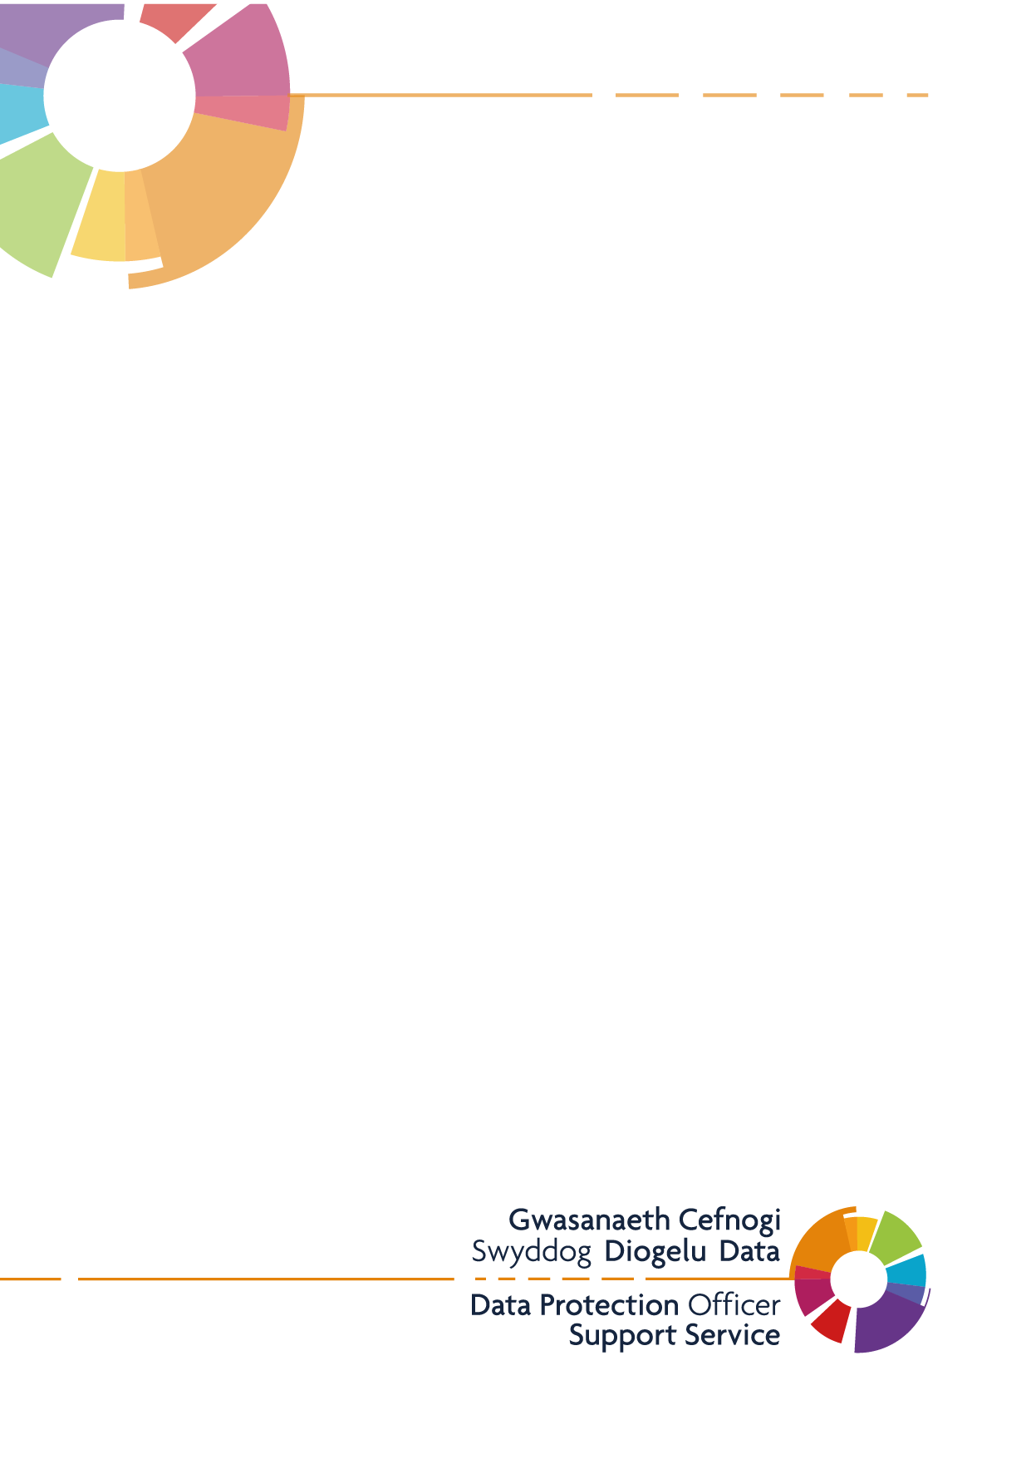
Mumbles Medical Practice
Publication Scheme

Introduction
This example publication scheme has been created to outline the types of information that the Practice is expected to publish. The example is based upon the ICO model publication scheme and is broken down into the classes of information required under the Freedom of Information Act 2000. It is recommended that this is laid out in its own section of your Practice’s website, with the below headings listed.
Your Rights to Information
The Freedom of Information Act (FOI) 2000 provides members of the public with the right access information held by public authorities.
Public authorities are required to routinely publish certain information to the public as part of its normal business activities. This is known as a publication scheme.
The Mumbles Medical Practice Publication Scheme is designed to signpost individuals to information we proactively release as and when it becomes available. The aim of this is to explain what information the practice makes available to the public and where possible to provide an easy method of accessing it.
The Publication Scheme contains seven classes of information, as follows, and information falling into each of these classes is published on our practice website:
- Who we are and what we do
- What we spend and how we spend it
- What are our priorities and how we are doing
- How we make decisions
- Our policies and procedures
- Register of members’ interests
- Services we offer
All the information we proactively release is available free of charge on our website. Our publication scheme is a useful place to start if you’re looking for information about Mumbles Medical Practice before making a Freedom of Information request.
Information that is not published under the FOI Publication Scheme can be requested in writing and the release of such information will be considered in accordance with the provisions of the FOI Act 2000.
To make a Freedom of Information request, please email contact the practice write to:
Practice Manager
Mumbles Medical Practice
10 West Cross Avenue
Norton
Swansea
SA3 5UA
Who we are and what we do
Mumbles Medical Practice has 7732 patients in the Practice Area. We are also a member of the Bay Health Cluster which is made up of 8 separate Practices.
The practice moved to its main surgery at West Cross Avenue in Norton in 1994
For information about who works at our practice, please see our website practice staff section: www.mumblesmedicalpractice.co.uk
What we spend and how we spend it
Mumbles Medical Practice receives money from NHS Wales according to its contract for national General Medical Services in exchange for services provided for patients.
The total income received from the NHS before expenses was £1,259,973 for the year ending 30/03/2023.
There may be circumstances where material cannot be released because it is confidential or commercial information or the appropriate officer designated for these purposes, under the Act, has taken the view that it may be prejudicial to the conduct of the Practice’s affairs.
If this is the case, we will respond to your FOI request with a formal letter acknowledging the reasons why we are unable to give you this information.
We do not wish to publish our annual salaries, but they are available on request.

What our priorities are and how we are doing
Working closely with our colleagues in the Bay Cluster to develop and improve services for patients in the local area.
Working towards achieving required standards such as Quality Assurance Framework (QAIF), Access Standards, Medicines Management, Patient Safety, IG toolkit and Clinical Governance Practice Self-Assessment Tool (CGPSAT).
Working with our neighbouring practice and the Health Board to continuously improve the services that are offered within Mumbles Medical Practice.
We implemented AskMyGp an online system which allows patients to submit a digital request to the practice.
In line with the Welsh Government Access Standards 2023/24 we offer a mix of telephone, face to face, urgent, on the day and pre-bookable appointments.
We have completed the NHS Patient Experience Survey for 2023/24 and will use the information to assist in planning for 2024/25.
The practice has not had a recent inspection from Health Inspectorate Wales (HIW). When we do have an inspection, the report will be published here
How we make decisions
Mumbles Medical Practice hold regular practice meetings that is made up of the GP partners, clinical staff and management.
Our Policies and Procedures
General policies and procedures in use within the practice include, but are not limited to:

Data Protection
General Management Policy
Records Management Policy
Call recording Policy
Caldicott Policy
Freedom of Information
All policies and procedures are available for viewing, upon request in writing, please contact the Practice Manager.
If you have a complaint or concerns about the service you have received from the doctors or any of the staff working in this practice, please let us know. We operate a complaints procedure as part of the NHS system. Our complaints system meets national criteria.

